**Frameworks Concepts**

Configure test ng in eclipse

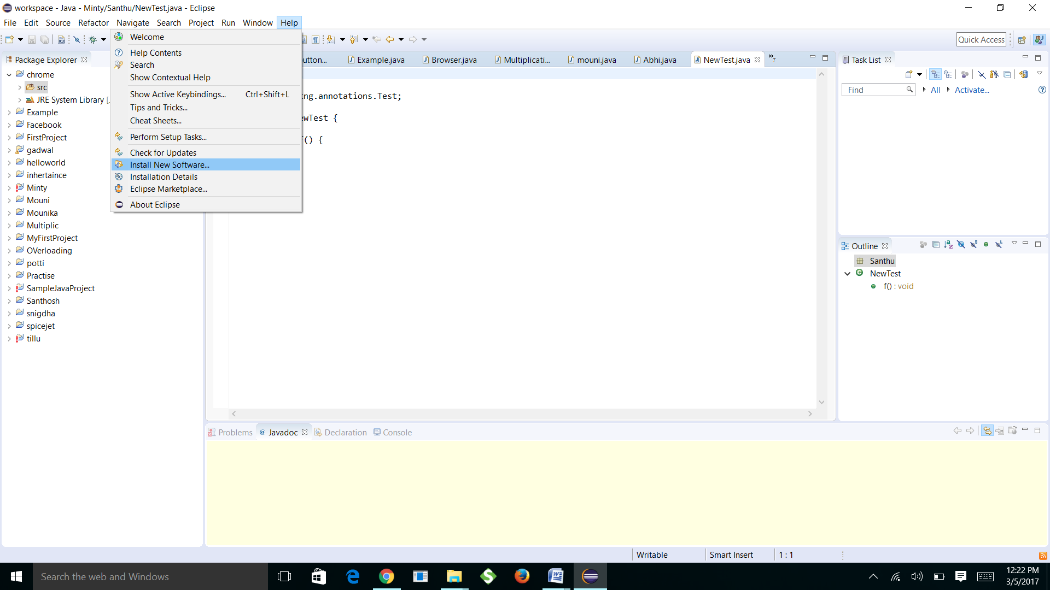

And then go to install new software Click add button .

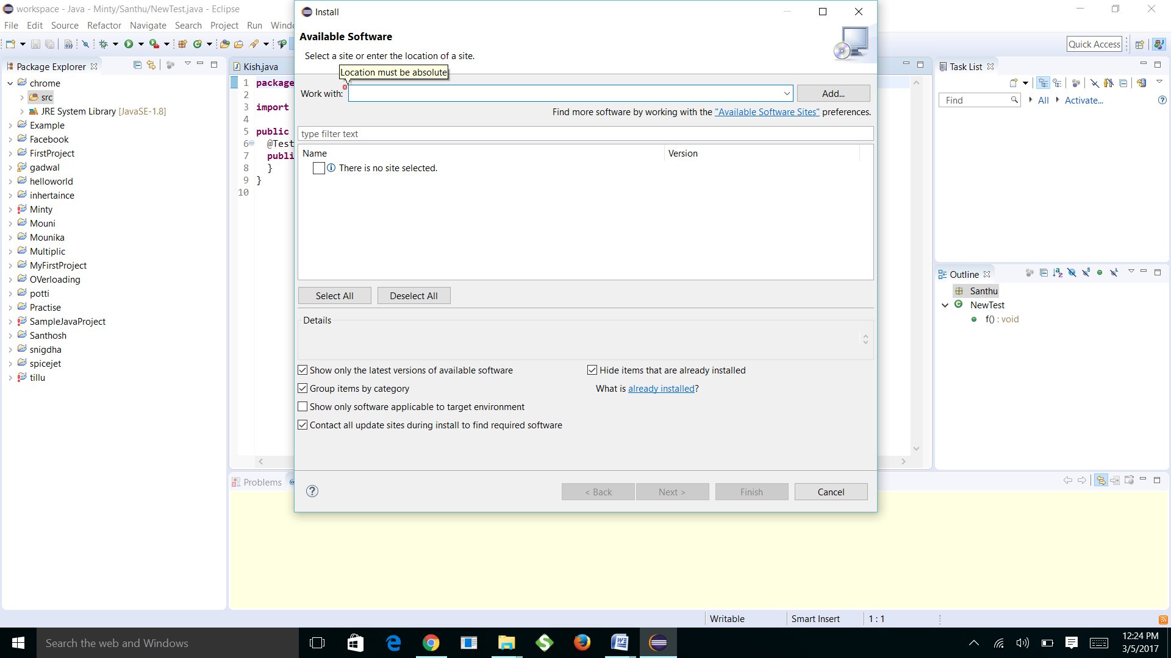

**Then go to add respoistory ,add name, location and click ok**

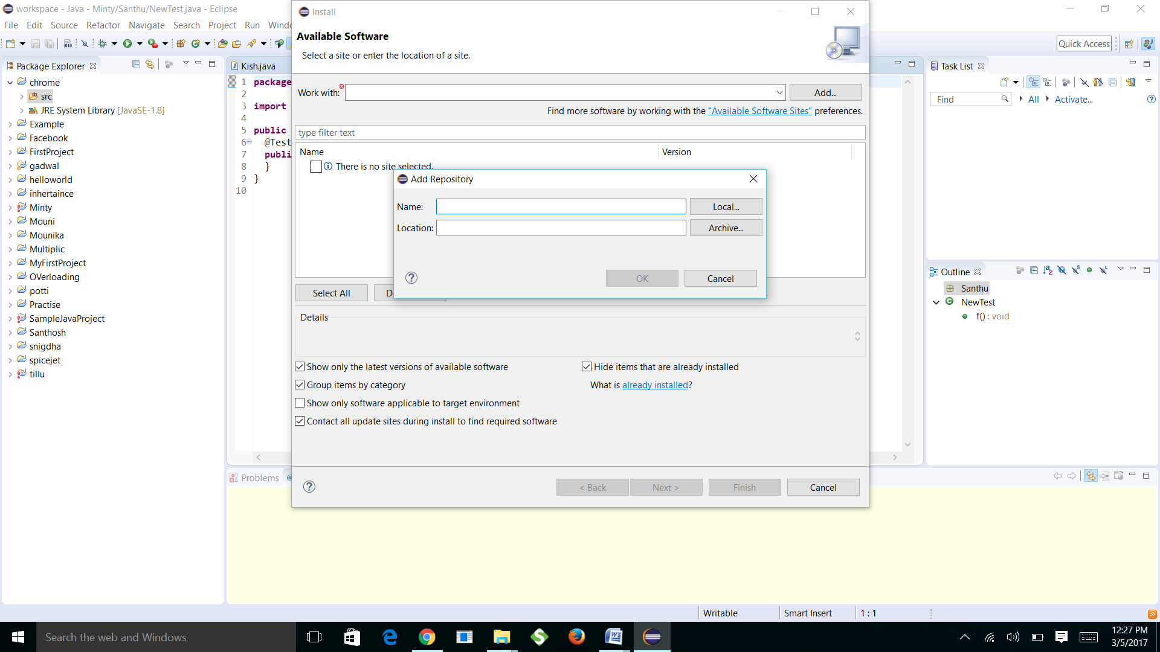

**then you will find this previous window,in that click TestNG next and finish**

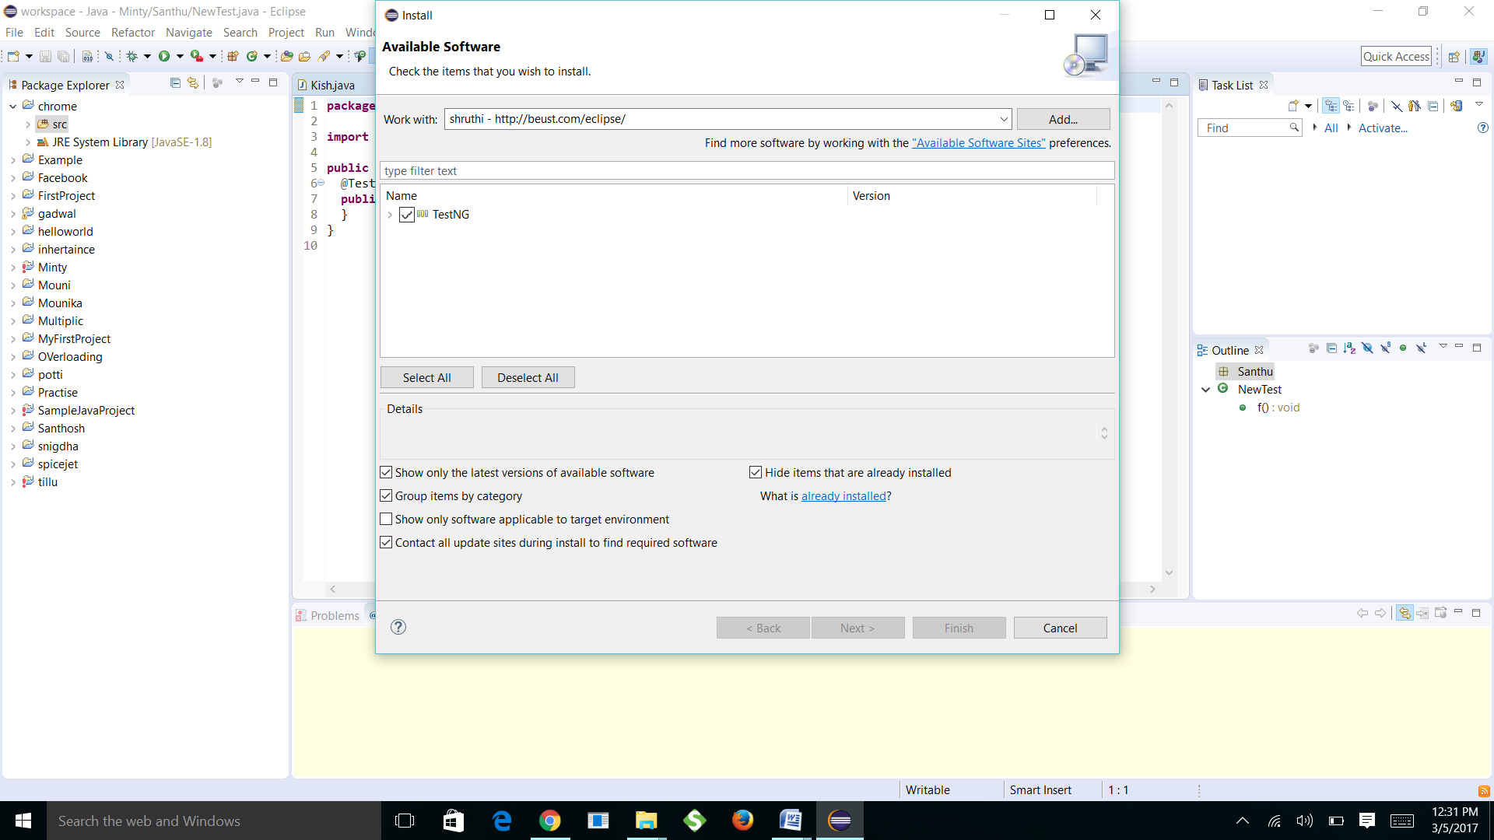

**And then accept the license finish and ok**

**It will restart again ,then your Test NG is installed in eclipse**

**You will find this window**

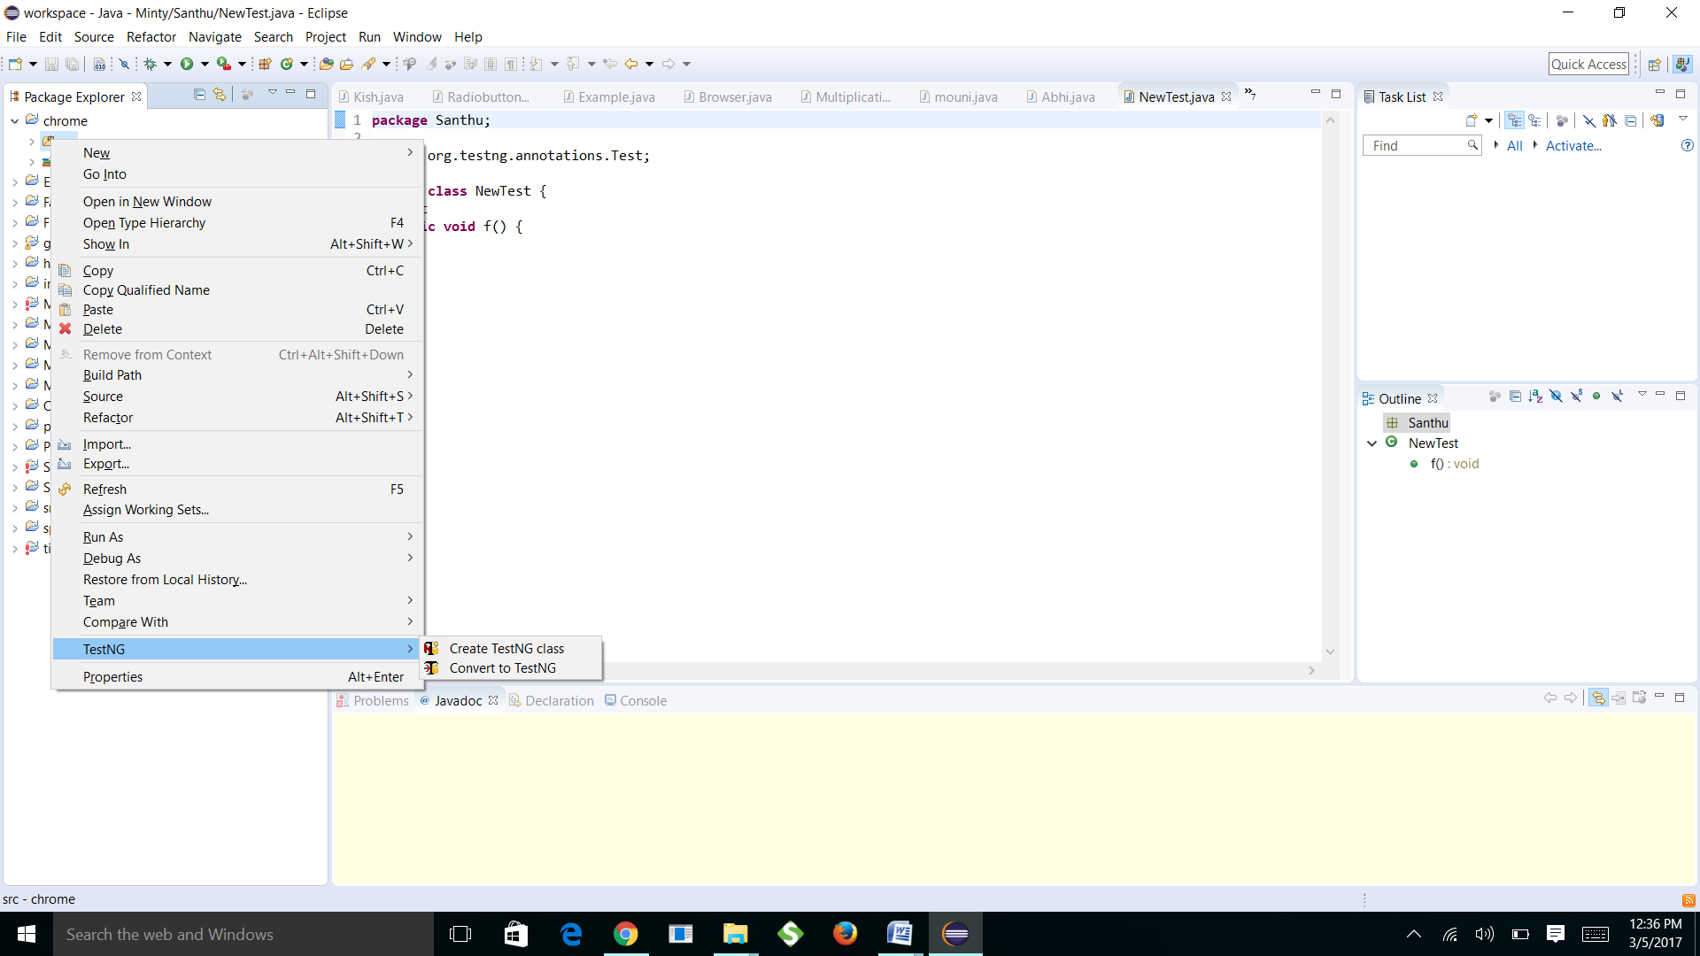

**2) Create methods with different annotation like**

**Different annotation like**

**@beforemethod @aftermethod @Dataprovider**

**@beforesuite @aftersuite**

**@beforeclass @afterclass**

**@beforetest @aftertest**

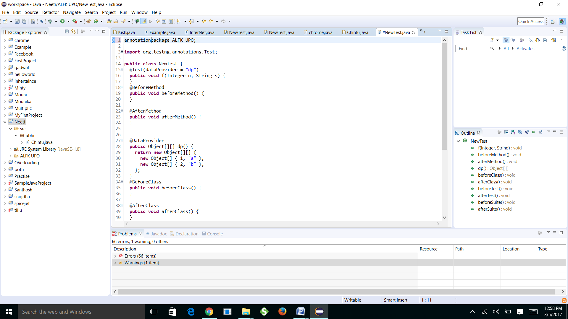

**What is page object model ?**

**Page Object Model is a design pattern to create Object Repository for web UI elements.**

**Under this model, for each web page in the application there should be corresponding page class.**

**This Page class will find the WebElements of that web page and also contains Page methods which perform operations on those WebElements.**

**Name of these methods should be given as per the task they are performing i.e., if a loader is waiting for payment gateway to be appear, POM method name can be waitForPaymentScreenDisplay().**

**What is page factory?**

**Page Factory is an inbuilt page object model concept for Selenium WebDriver but it is very optimized.**

**With the help of PageFactory class we use annotations @FindBy to find WebElement. We use initElements method to initialize web elements.**

**@FindBy** can accept **tagName, partialLinkText, name, linkText, id, css, className, xpath**as attributes.

**(4 )creating jar files using that jar files in selenium concepts**

**In** Eclipse. Create a new Java project.

Add Selenium server jar as external jar file to your project. To do this, right click on any file/folder in the project in Eclipse. Select Build Path -> Configure Build Path. Select 'Libraries' tab. Click on 'Add external jar'. Select the Selenium server jar file you have previously downloaded.

Use TestNG library in your project: right click on any file/folder in the project in Eclipse. Select Build Path -> Configure Build Path. Select 'Libraries' tab. Click on 'Add Library'. Select TestNG. Click 'Ok'.

A TestNG testsuite comprises of number of tests. A TestNG 'test' comprises of one or more classes, and a TestNG class consists of multiple 'Test Methods'.

Add a new Java class 'TestClass1' to the project.

**Add following TestNG testsuite to your project as 'TestNG.xml'**

**Execute above TestNG testsuite by right clicking on the TestNG.xml and selecting Run as -> TestNG suite. The testcases are executed and the summary of test execution is shown in Eclipse's console.**

**TestNG suite was executed successfully! Now we want to use Ant to run the TestNG testsuite, instead of eclipse. We need to specify location of Selenium server jar and TestNG jar to Ant. Let's create a new folder in the project and put the jar files there.**

**Create a folder 'lib' in your Java project.**

**Copy Selenium server jar to this 'lib' folder.**

**Copy testng.jar too, in the same folder. In you Eclipse directory, go to plugins directory.**

**Following this link for junit course**

